TopCoder Studio and Cockpit Download All Submissions Feature Deployment Guide

Revision History
Author | Revision Number | Date
isv | 1.0 | 01/30/2012

Deployment Instructions 3
1. Organization of Submission 3
2. Application Setup 3
2.1 Ant .Properties File 3
2.2 Build Scripts Setup 4
3. Database Setup 4
4. Deployment Instructions 4
5. Starting 4
6. Verification 5
7. Resource Contact List 15

Deployment Instructions

Organization of Submission

The content of submission follows directory structure provided below:

direct

Contains the sources for TopCoder Direct application added/updated in the course of this assembly. This directory replicates the application development distribution structure and includes only updated and new files.

docs

Contains this document which is the Deployment Guide for the TopCoder Studio and Cockpit Download All Submissions Feature assembly.

test_files

Contains the SQL scripts with sample test data to be used for review purposes only.

web_module

Contains the configuration, libraries, sources for Studio application developed/updated in the course of this assembly. This directory replicates the application development distribution structure and includes only updated and new files.

reviewers.readme

Contains the instructions for reviewers for deploying/testing application in VM environment.

Application Setup

The application is expected to be deployed to the following environment:

TC Direct application:

JRE 1.5
JBoss 4.2.3.GA
Informix DS 11.0

TopCoder Studio application:

JRE 1.5
JBoss 4.0.4.GA
Informix DS 11.0

Ant .Properties File
No new configuration parameters have been defined by this assembly.

Property Name | File property is stored | Example Setting

Build Scripts Setup

The build script for TopCoder Direct application (build.xml) provides the following targets which are to be used:

- deploy – builds and deploys the TopCoder Direct application to target server.

The build script for Studio application (build-studio.xml) provides the following targets which are to be used:

- deploy – builds and deploys the Studio web application to target server.

Database Setup

Follow the instructions from TopCoder Databases Deployment Guide document from http://www.topcoder.com/wiki/display/docs/TopCoder+Databases+Setup+Guide for setting up the database.

No changes to existing databases have been introduced with this assembly.

Deployment Instructions

This section provides the instructions for integrating and deploying the changes from TopCoder Studio and Cockpit Download All Submissions Feature assembly in Production environment.

- Merge the updated/new code from direct directory in this submission into development distribution for TC Direct application
- Merge the updated/new code from web_module directory in this submission into development distribution for TopCoder Studio application
- Build and deploy TopCoder Direct application using ant deploy command
- Copy static files for TopCoder Direct to /mnt/apache/tcdocs directory using ant deploy-apache-static command.
- Build and deploy TopCoder Studio web application using ant –f build_studio.xml war-studio command

If necessary consult following online documentation for details on building and deployment of TopCoder Direct application:

http://apps.topcoder.com/wiki/display/docs/TC+Direct+Setup+Guide

Starting

- Build and deploy the TopCoder Direct application
- Start JBoss server instance hosting TopCoder Direct application
- Build and deploy the Studio web application
- Start JBoss server instance hosting Studio web application
- Start Apache HTTP server

Verification

- Login to TopCoder Studio application as submitter using URL like http://studio.cloud.topcoder.com and having Remember Me box checked
  - The user must be logged to application successfully

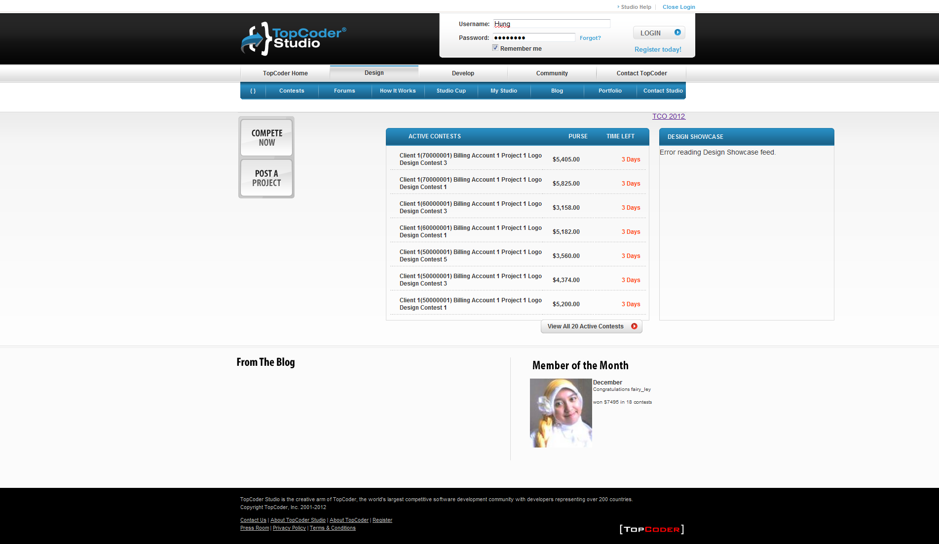

- Click Contests tab and once the Active Contests page is displayed click Submit & Rank button for desired contest and submit a submission for contest
  - The submission must be submitted to server successfully
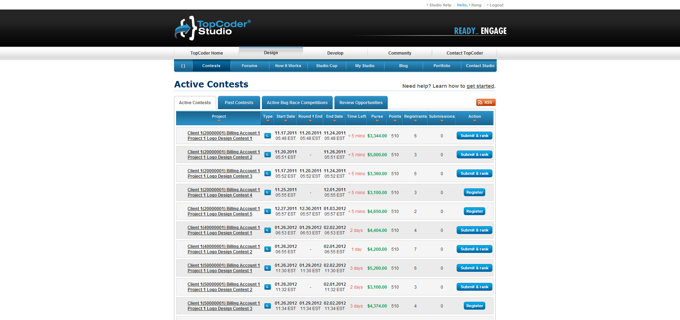

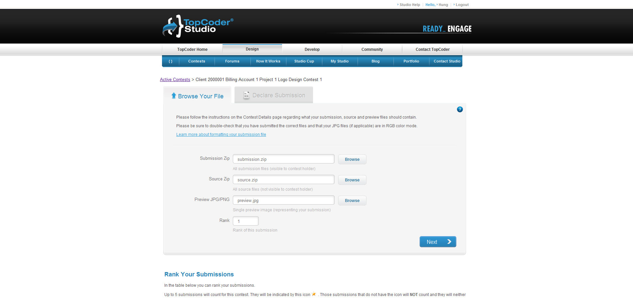
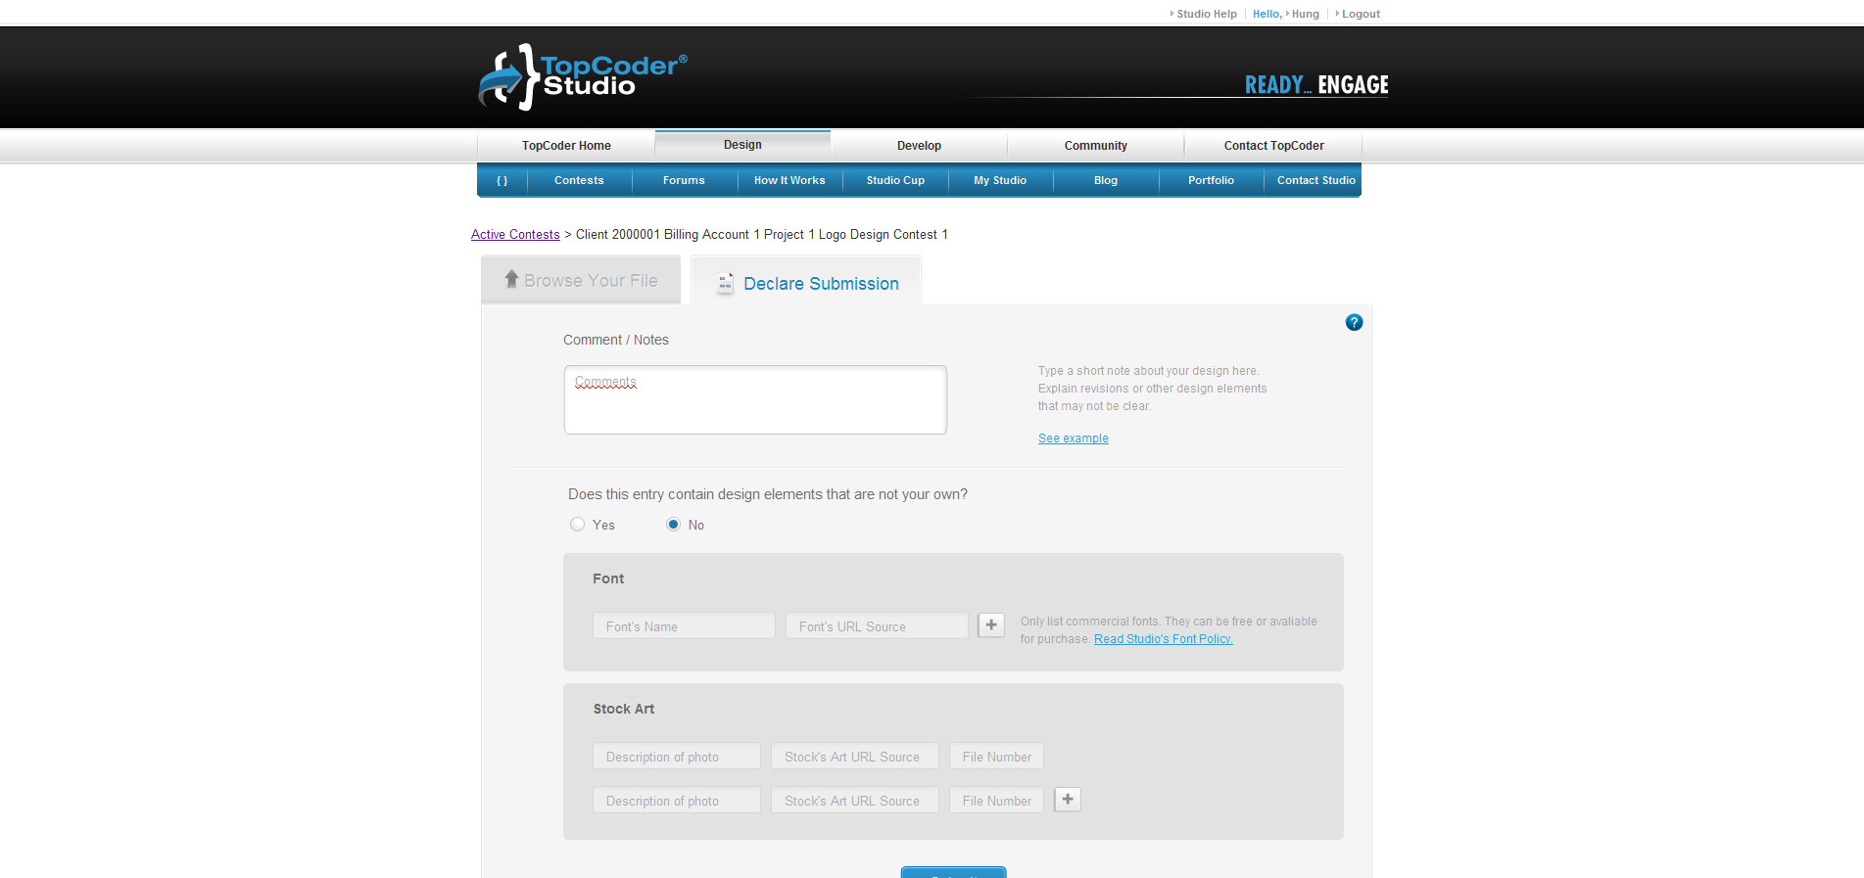

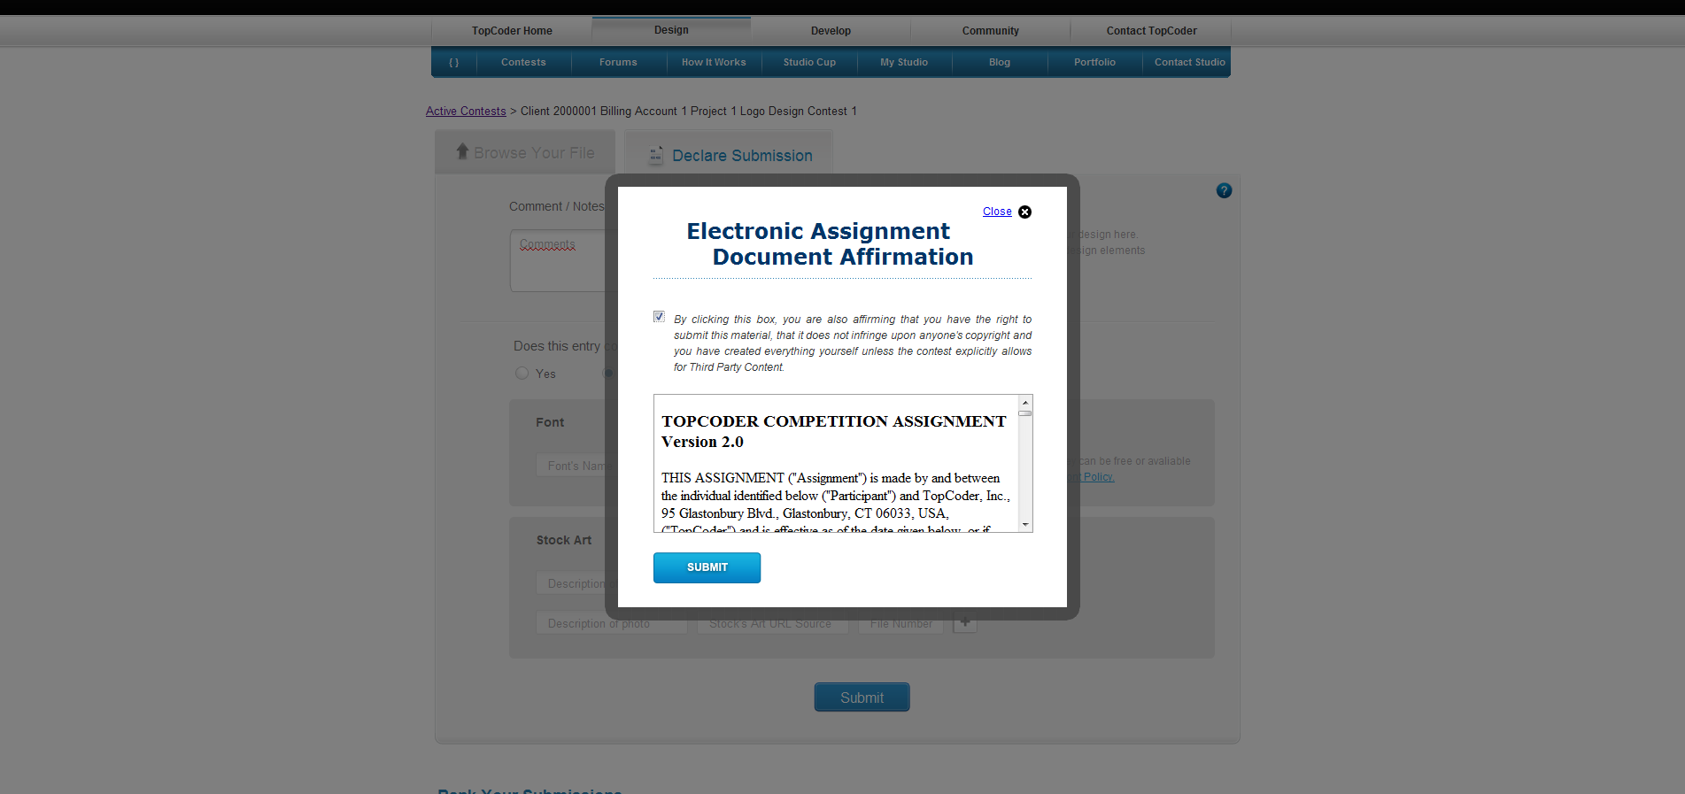
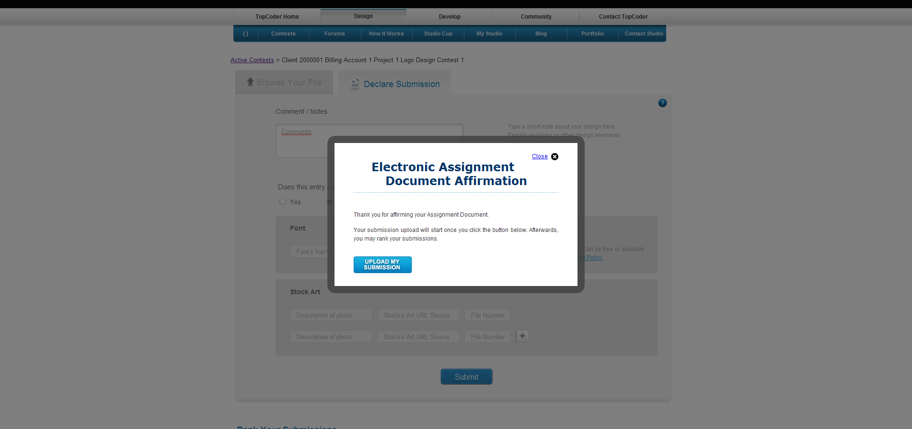

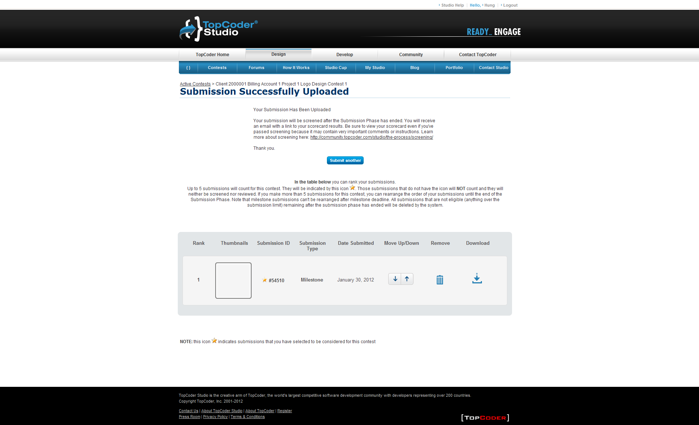

- Click Logout link at the top
  - The user must be successfully logged out

- Login to TopCoder Studio application as contest manager using URL like http://studio.cloud.topcoder.com and having Remember Me box checked
  - The user must be logged to application successfully

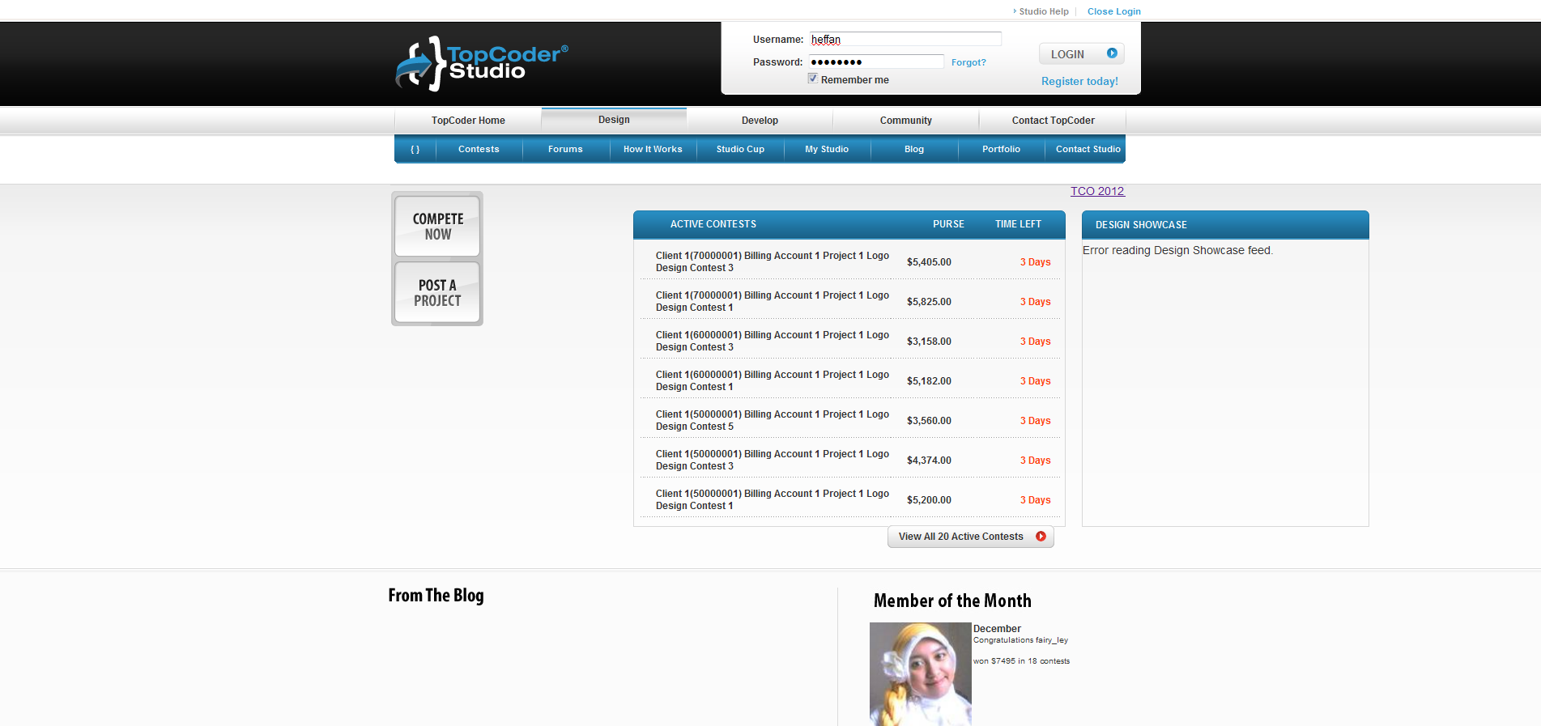

- Login to TC Direct application as same contest manager as logged to TopCoder Studio application using URL like http://cockpit.cloud.topcoder.com/direct/
  - The All Active Contests page must be displayed.

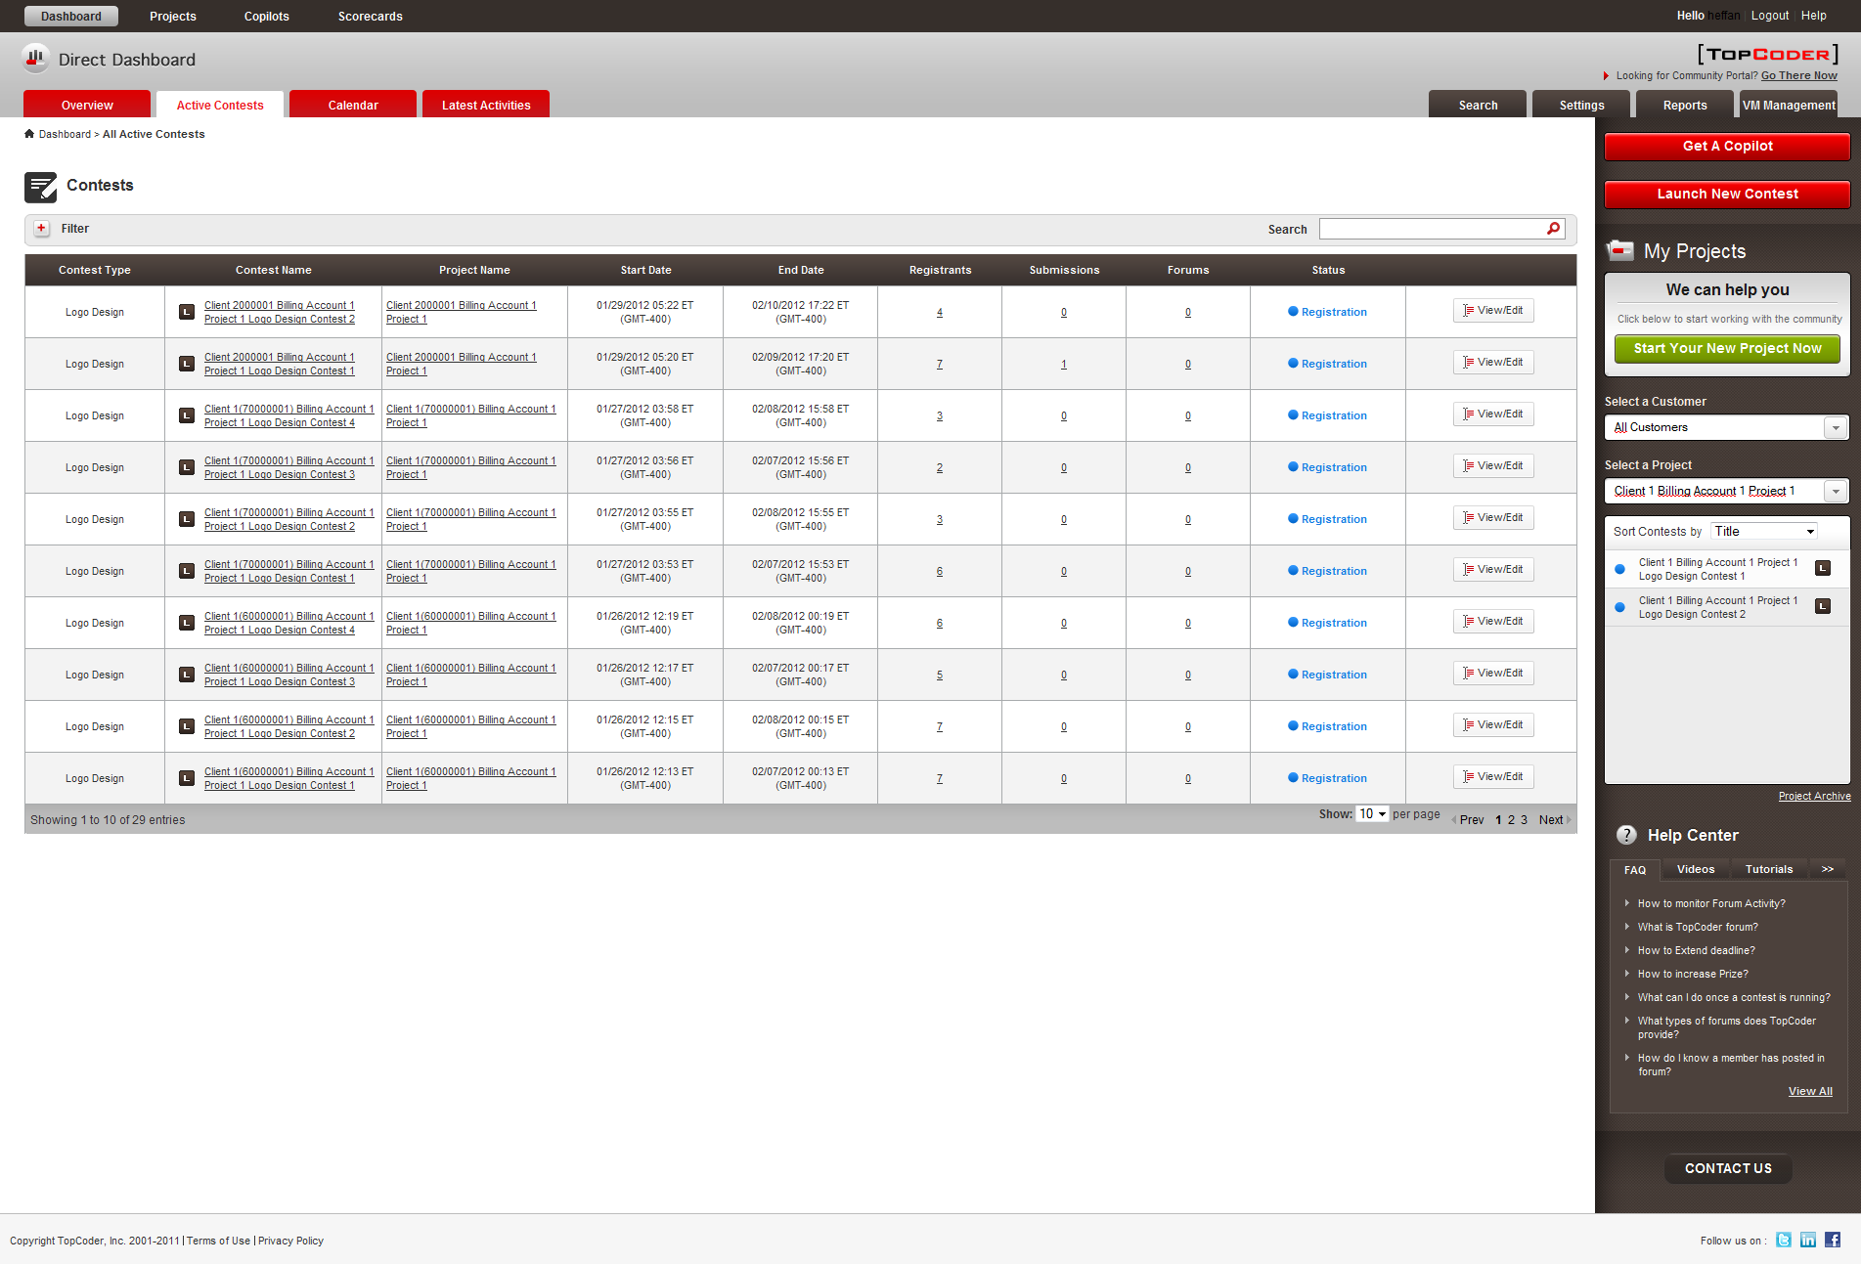

- Click the number in Submissions column for desired contest which the submitter above have submitted to.
  - The page listing the available submissions must be displayed. The page must display the Download All button

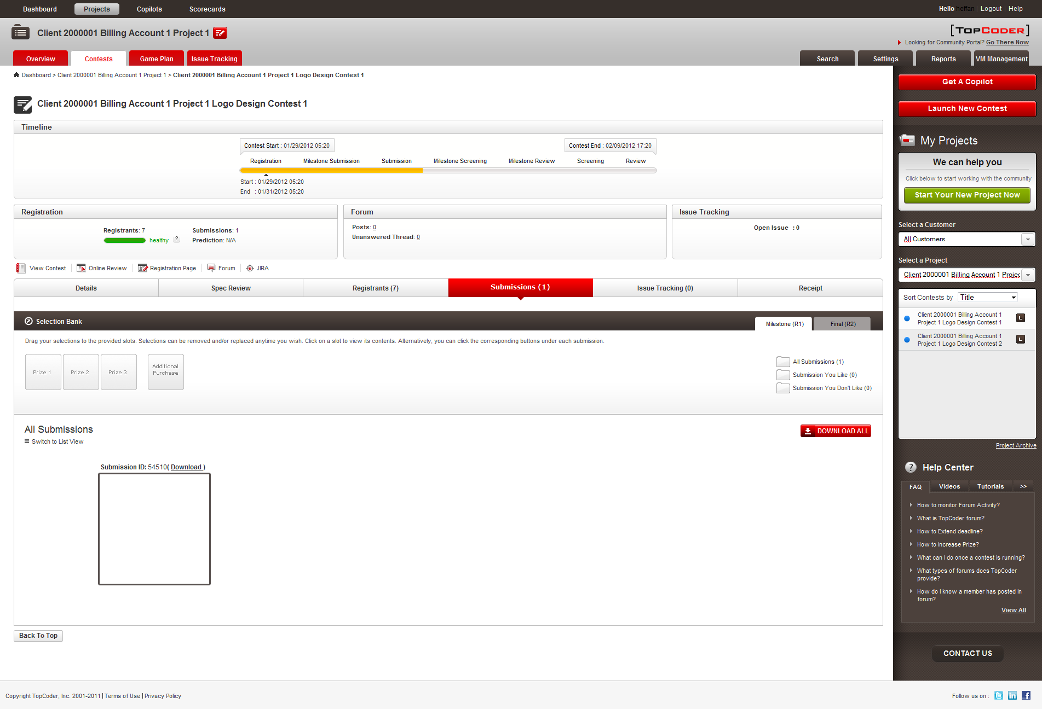

- Click DOWNLOAD ALL button
  - The process of downloading of all submissions for contest must start and file should be downloaded successfully.

- Check the downloaded archive
  - The archive should contain separate folder for each of downloaded submissions. Each folder must be named with submission ID. Each folder must contain preview files only (e.g. those which have been submitted by user with the ZIP file in Submission Zip input at step 2) since project is not finished yet

- Select from Select a Project drop-down on the right-hand panel a project which has completed contests and once the Project Overview page is displayed select the desired contest from the list on the right-hand panel and once Contest Details page is displayed click Submissions tab
  - The page listing the available submissions must be displayed. The page must display the Download All button

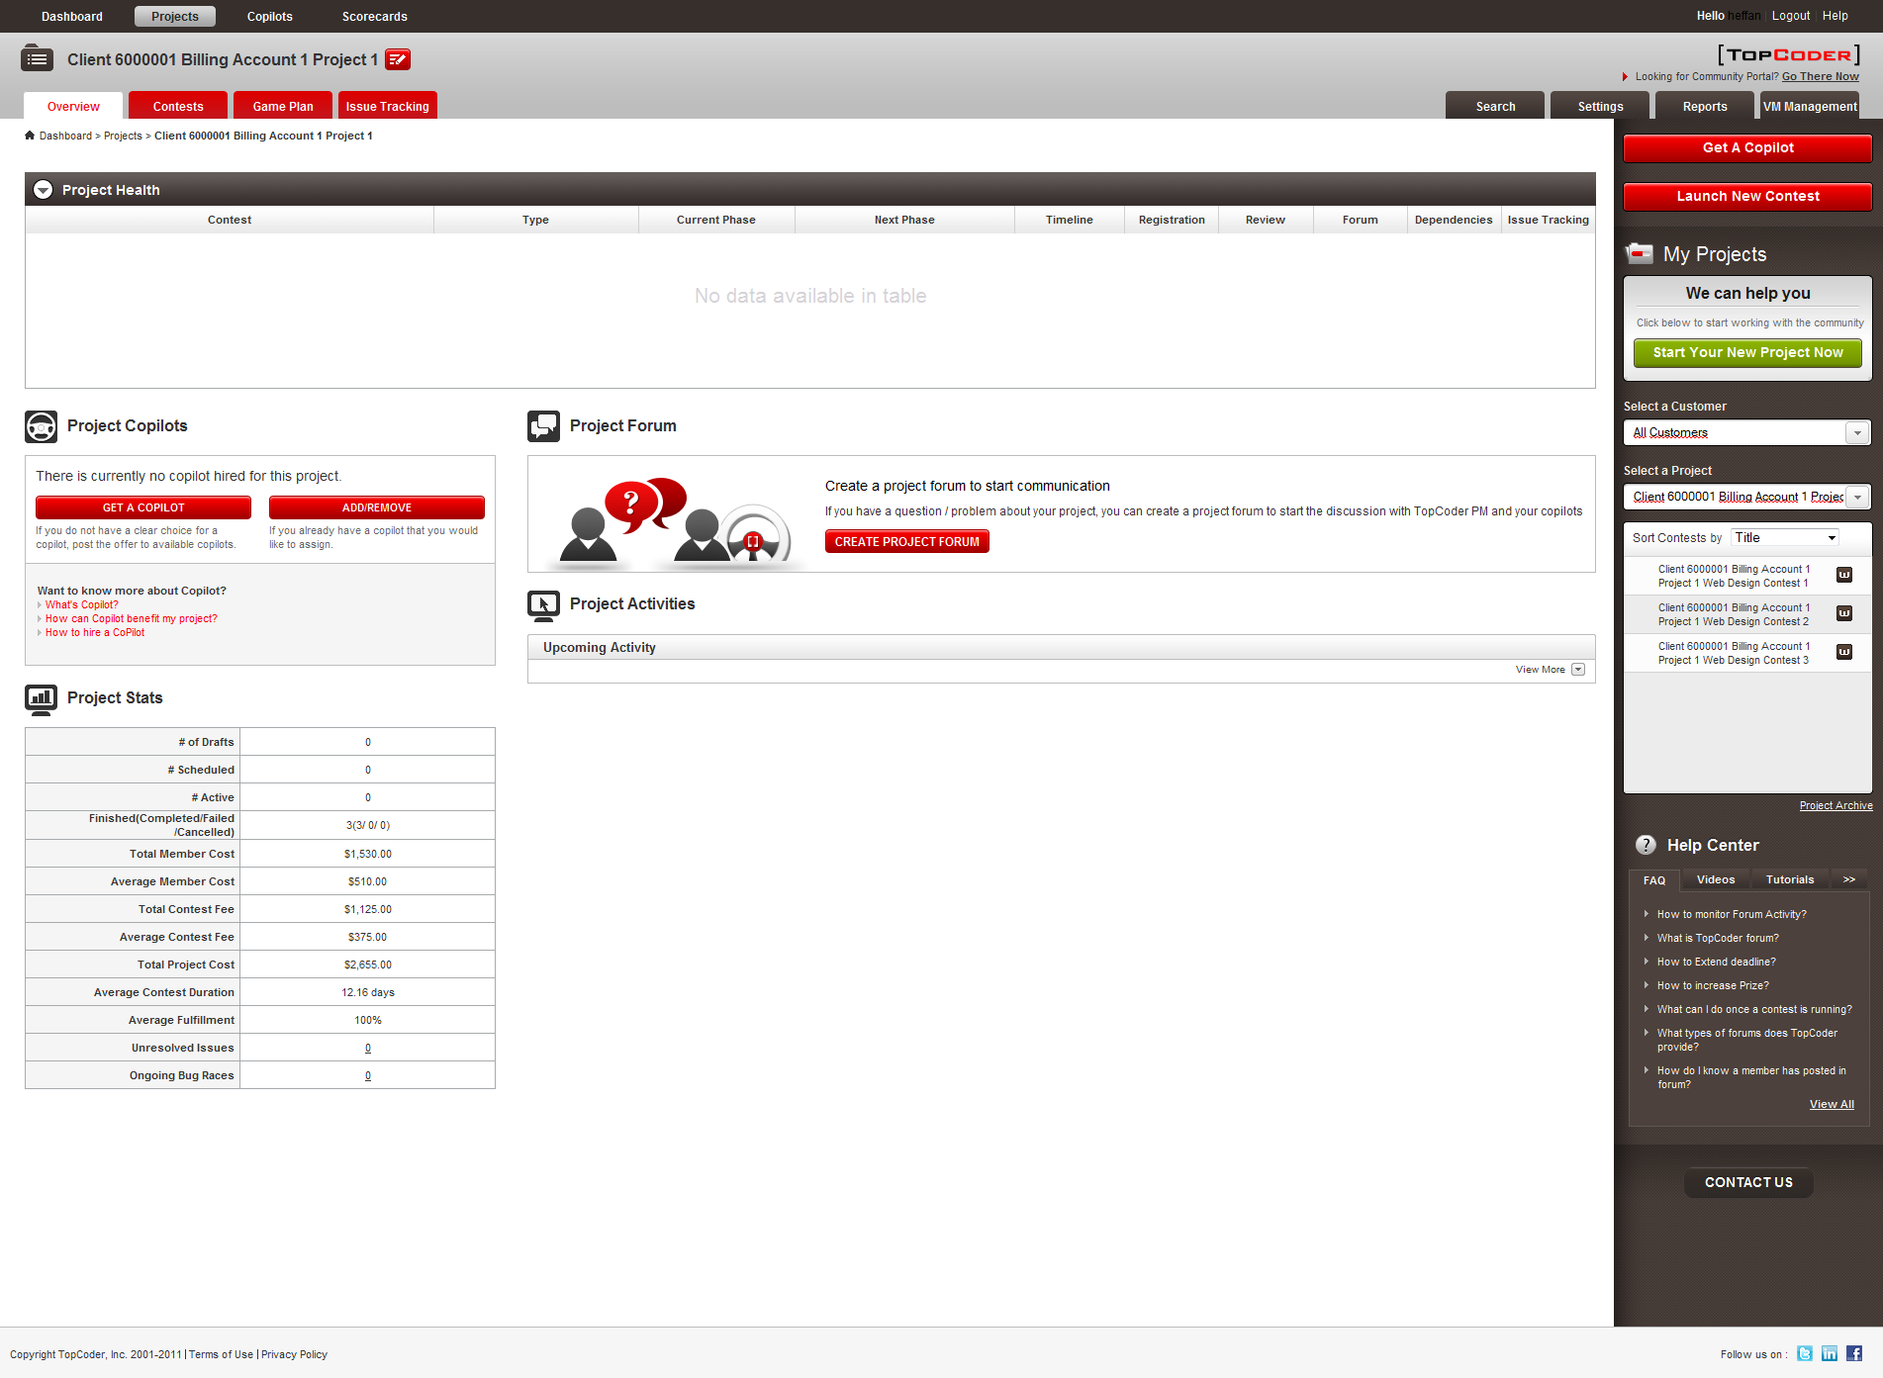

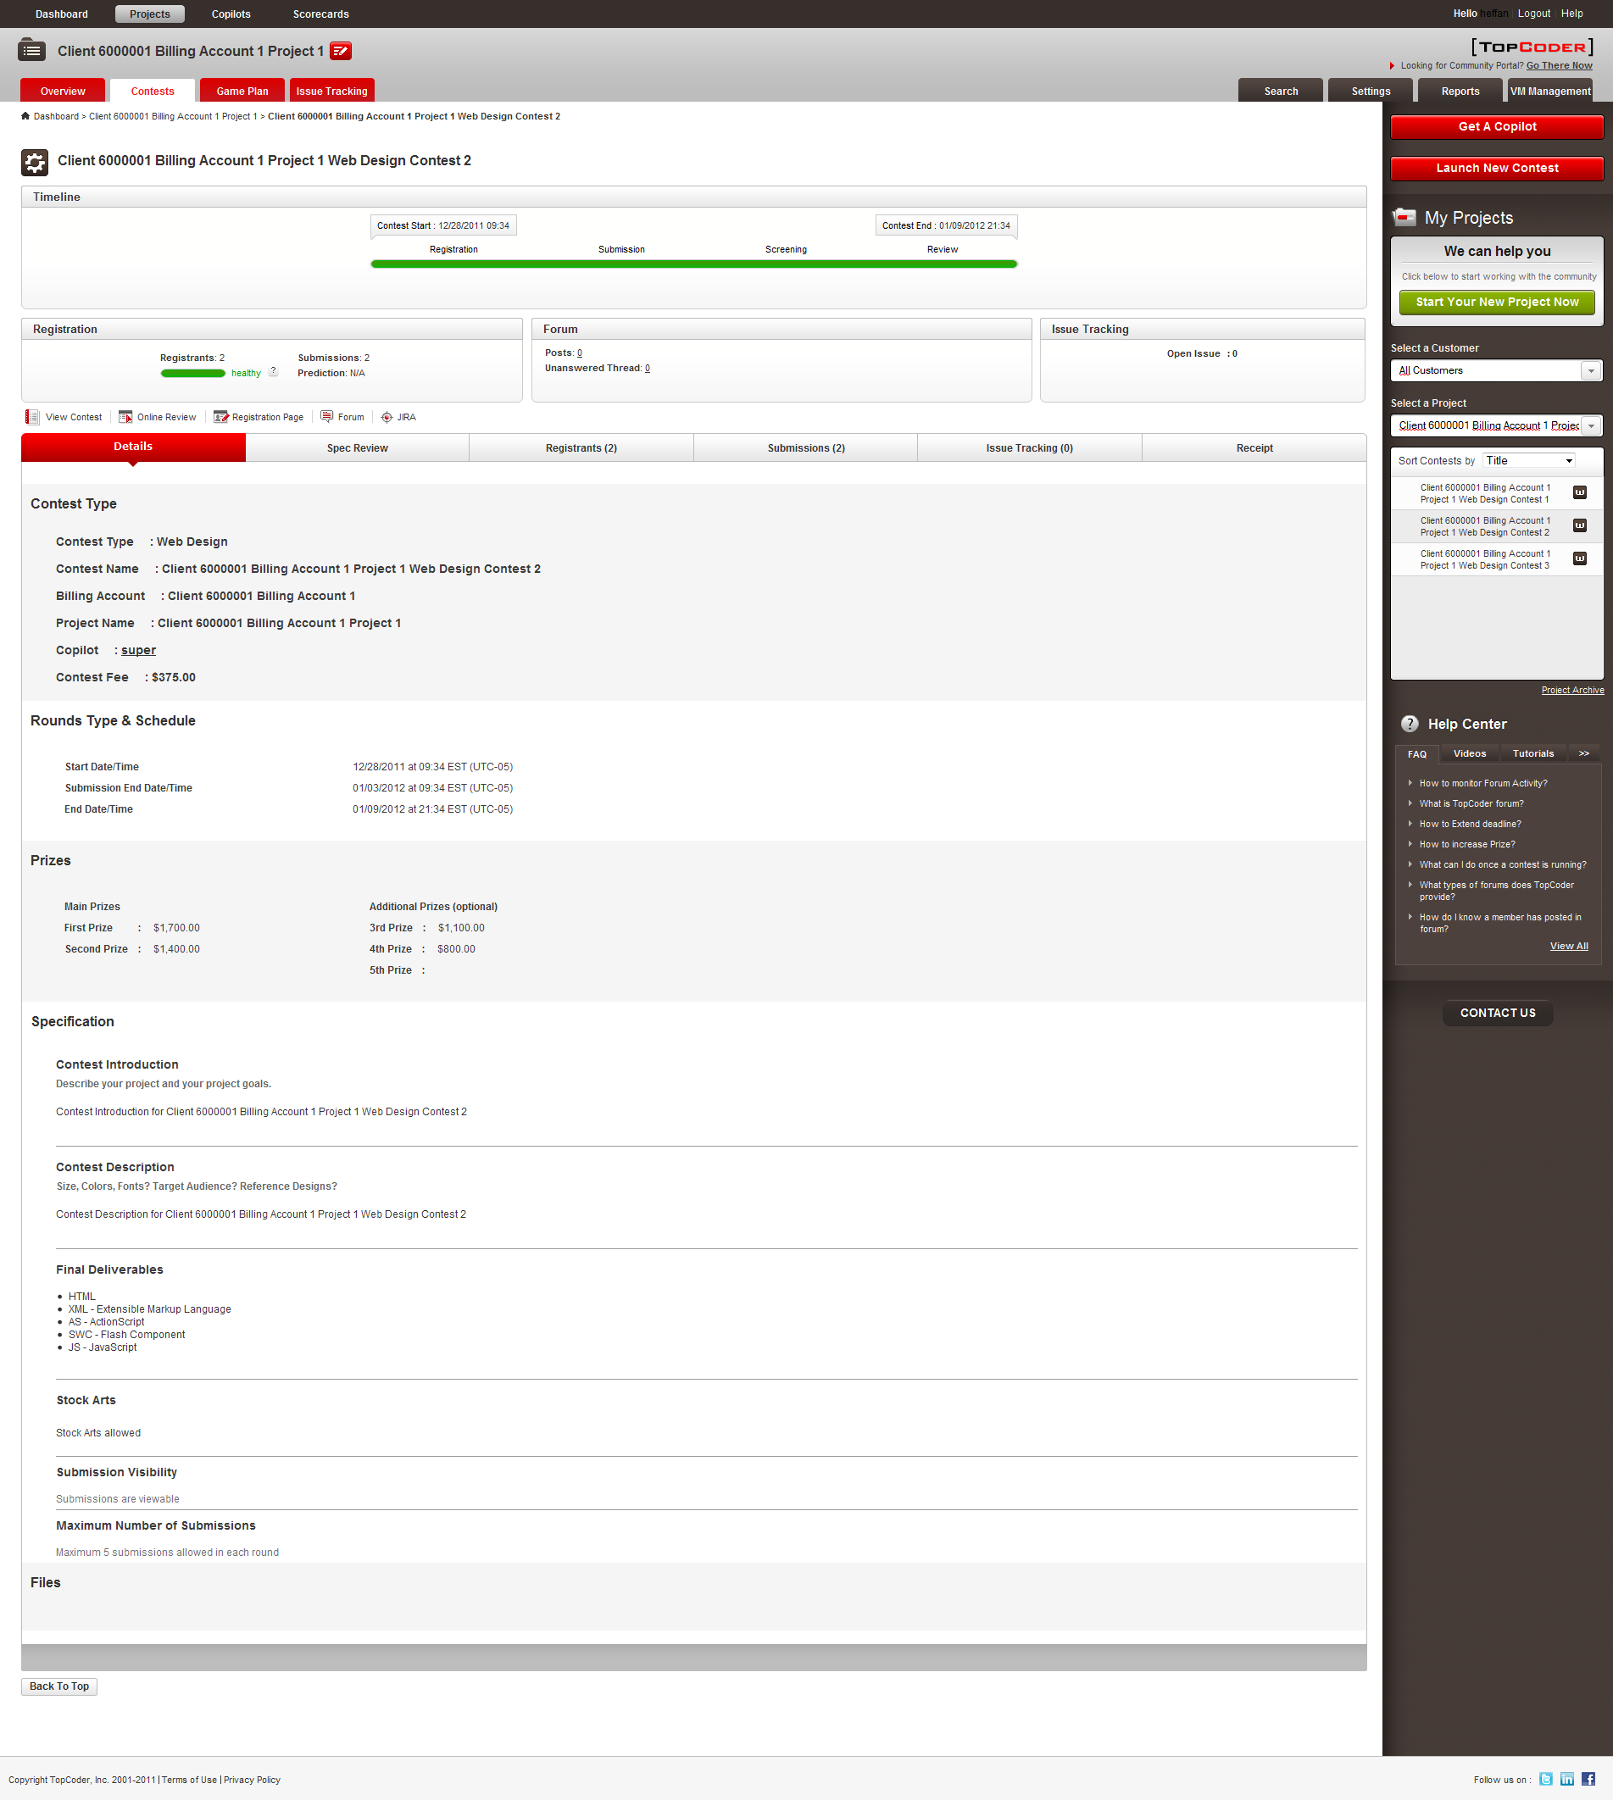
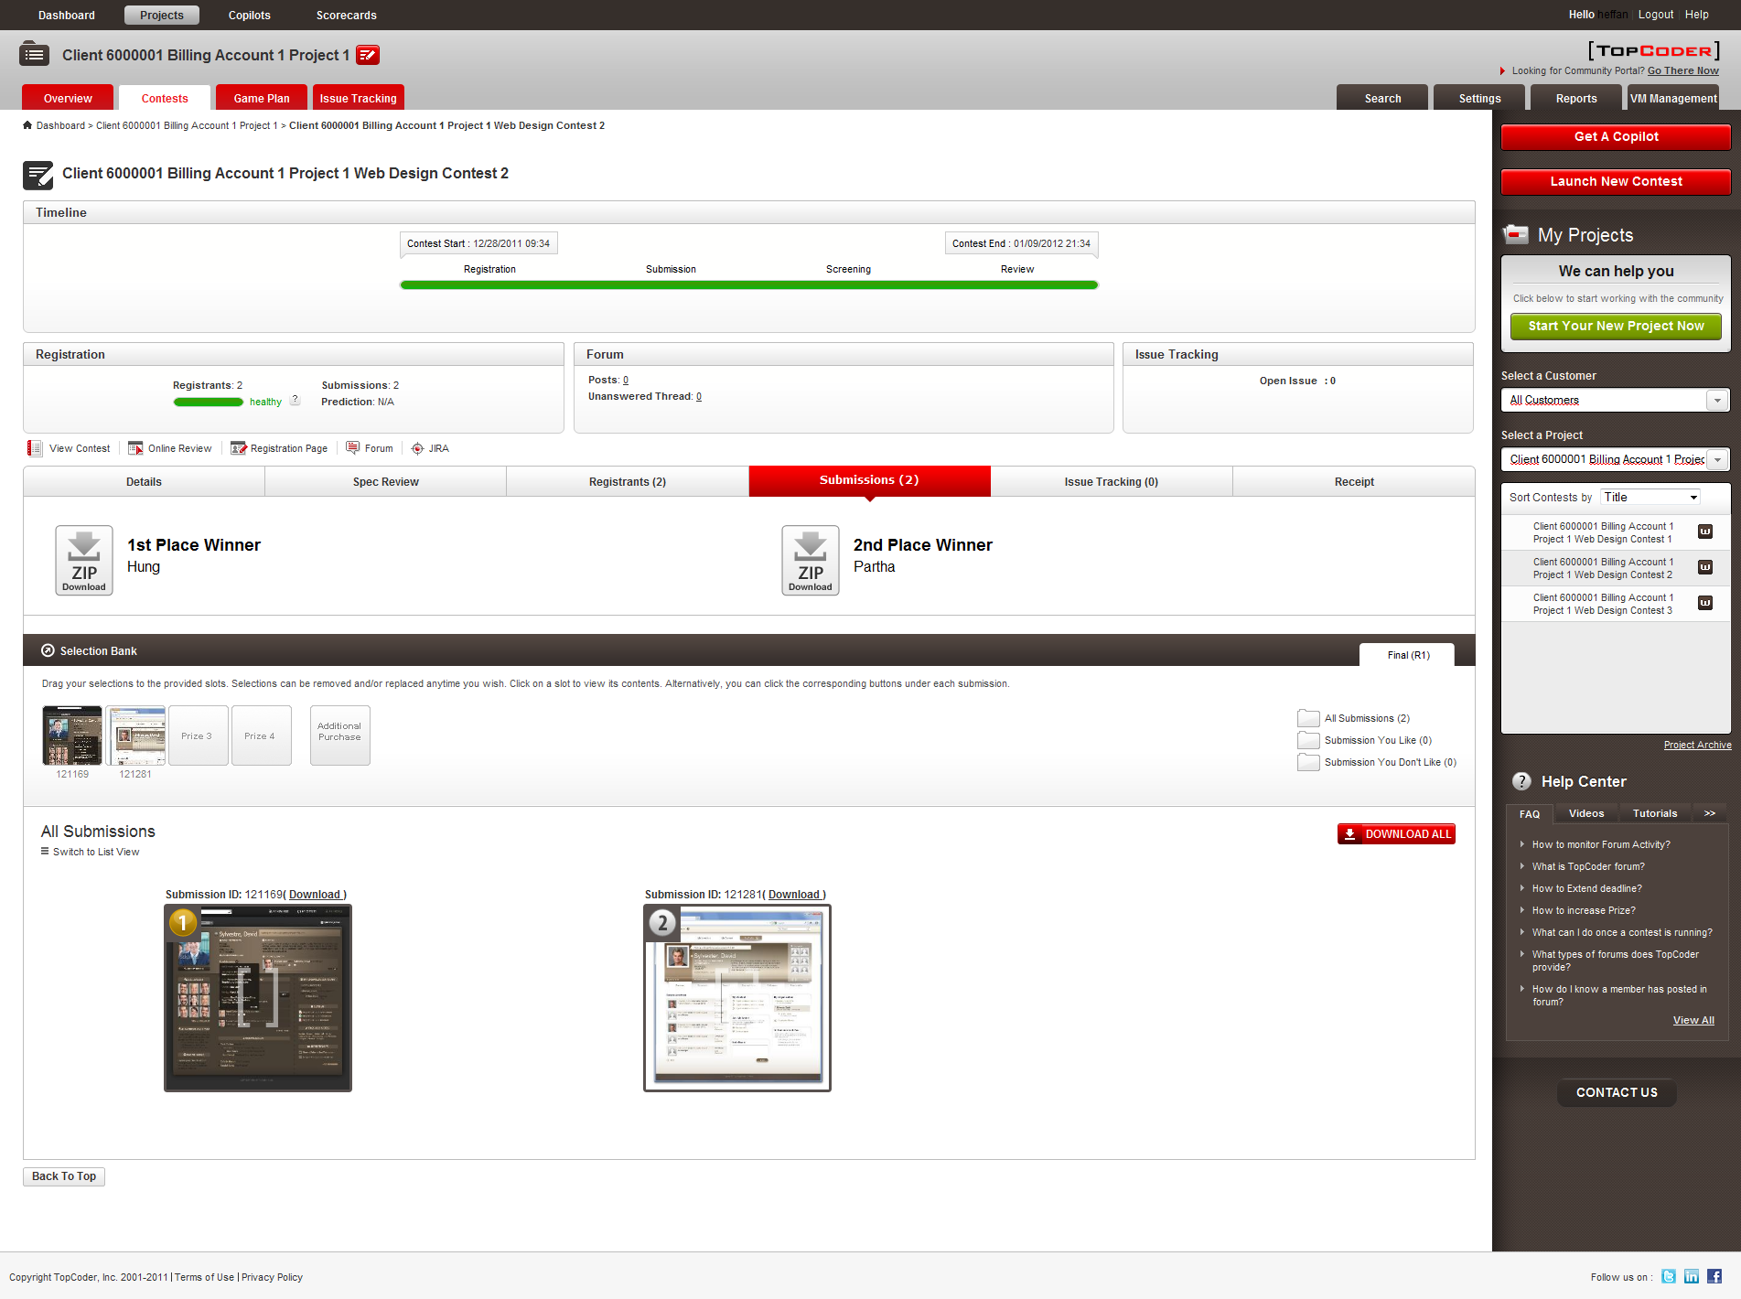
- Click DOWNLOAD ALL button
  - The process of downloading of all submissions for contest must start and file should be downloaded successfully.

- Check the downloaded archive
  - The archive should contain separate folder for each of downloaded submissions. Each folder must be named with submission ID. Each folder must contain source and submission subfolders. The submision subfolder must contain preview files only (e.g. those which have been submitted by user with the ZIP file in Submission Zip input at step 2) and preview image. The source subfolder must contain source files (e.g. those which are submitted by user with ZIP file in Source Zip input at step 2)

Resource Contact List

Name | Resource Email
isv

